**Quandl QA Dev Assessment Question #2:**Using  the  framework  or  tool  of  your  choice  develop  a  small  test  application  that  tests  the   following  parts  of  our  API.

•   Ensure  our  database  API  returns  a  list  of  databases

•   Ensure  our  dataset  API  returns  data  for  any  dataset  (of  your  choice)  in  the  ‘GOOG’   database.

  More information on this database can be found here:  quandl.com/GOOG

•   Ensure  our  datatable  API  returns  data  for  the  `WIKI`  database  with  a  valid  API  key

**Framework/Tools used:**

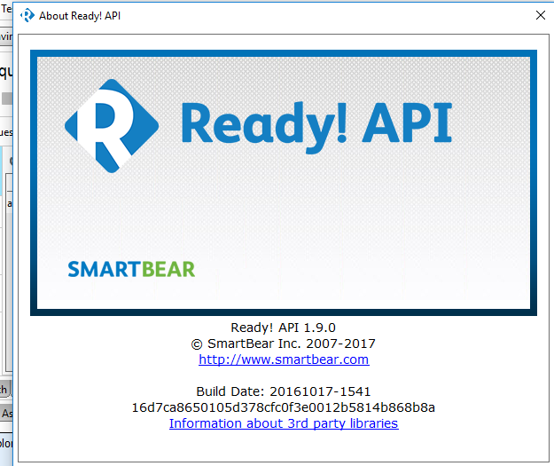

**Location of Video on GitHub:** Quandl\ API Test\2017-02-05_ReadyAPITestExecutionVideo

The video capture shows the steps to execute all the test cases step by step. To play the video, Open your web browser on your computer. You can use virtually any web browser to open **SWF files**, including Internet Explorer, Chrome, Safari, Firefox, and others. Click and drag the **SWF file** into your browser **window**. Release the **file** in the browser **window**.

**Test1: Ensure our  database  API  returns  a  list  of  databases**

**Location of file on GitHub**: Quandl\API Test\REST-Project-1-ListofDB.xml

**Steps to run the Test:**

1.Open ReadyAPI

2.Import the file using File->Import Project and browse to the folder where the .xml file

Resides.

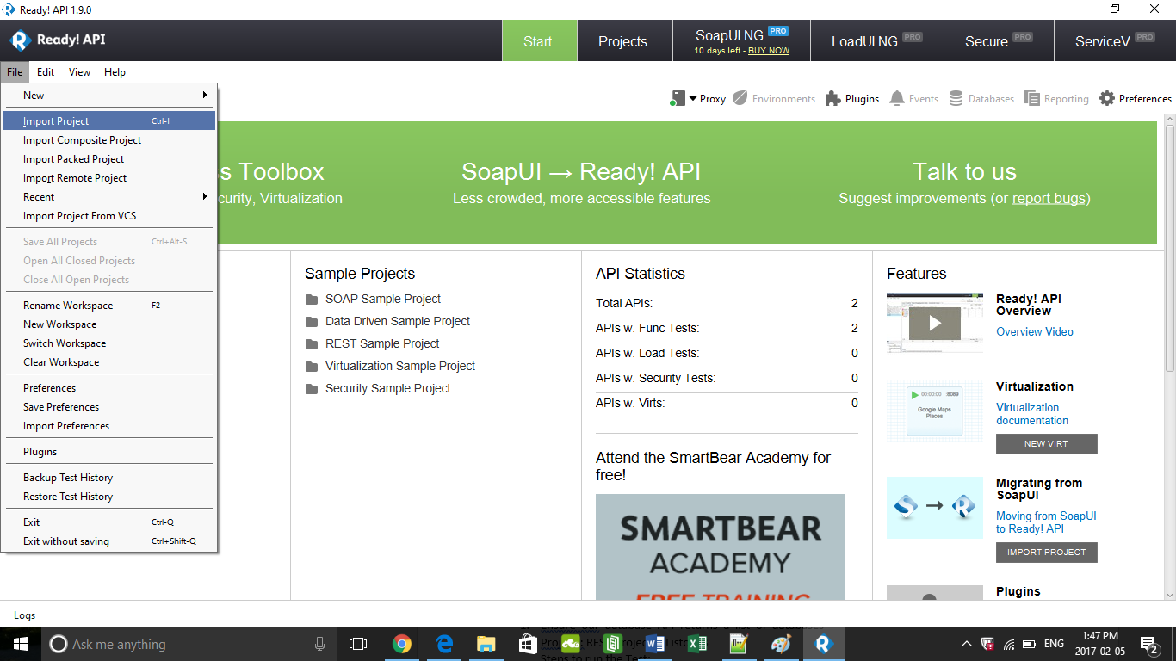

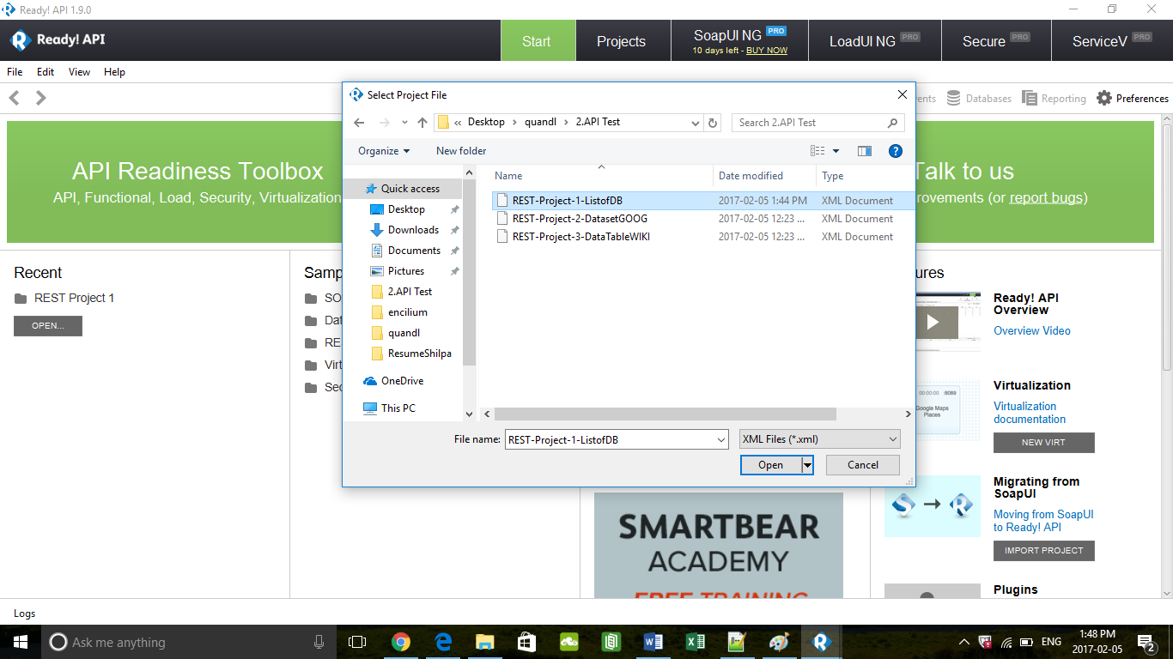

3.This is the view of the project opened in the Ready API. The “Execute” button is used to submit the request. The assertions box shows the assertions I have created to verify the response from the API.

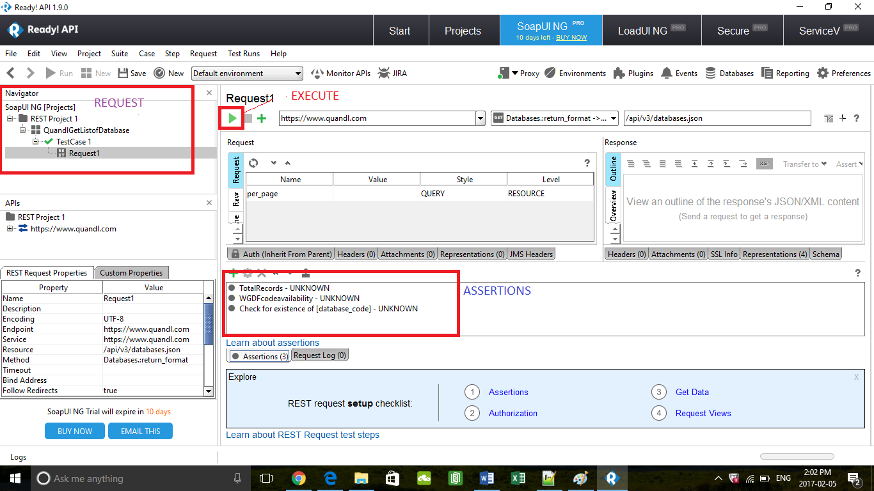

4.Click the Execute /Submit button to send the request and the below screenshot shows that the test case is successful .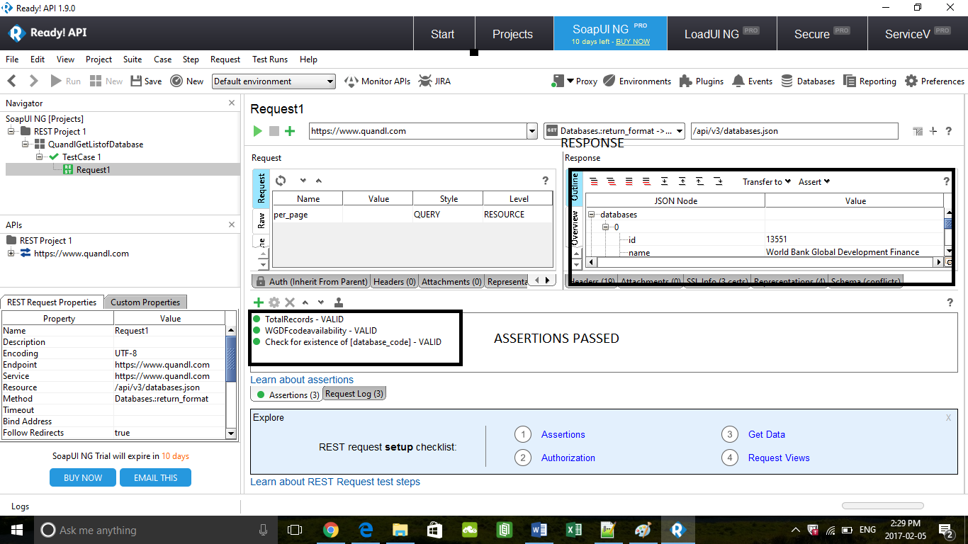

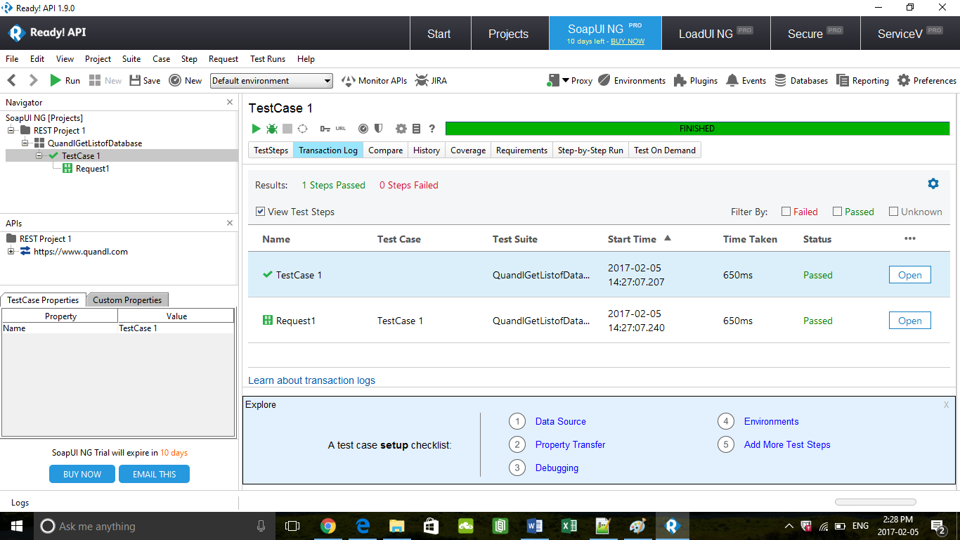

**Verified the following test scenarios from the API response :**

1. Total number of records returned is 100.
2. Existence of Database code ‘WGDF’
3. Existence of Database code ‘UINC’

**Test 2: Ensure  our  dataset  API  returns  data  for  any  dataset  (of  your  choice)  in  the  ‘GOOG’   database.  More  information  on  this  database  can  be  found  here:  quandl.com/GOOG**

**Location of file on GitHub**: Quandl\API Test\REST-Project-2-DatasetGOOG

1. Please follow the steps from above to execute the testcase.

2.**Verified the following test scenarios from the API response :**

1) Database id is 393

2)Dataset code is LON_LOND

3)Database code is GOOG

3.The snapshot of successful run is shown below.

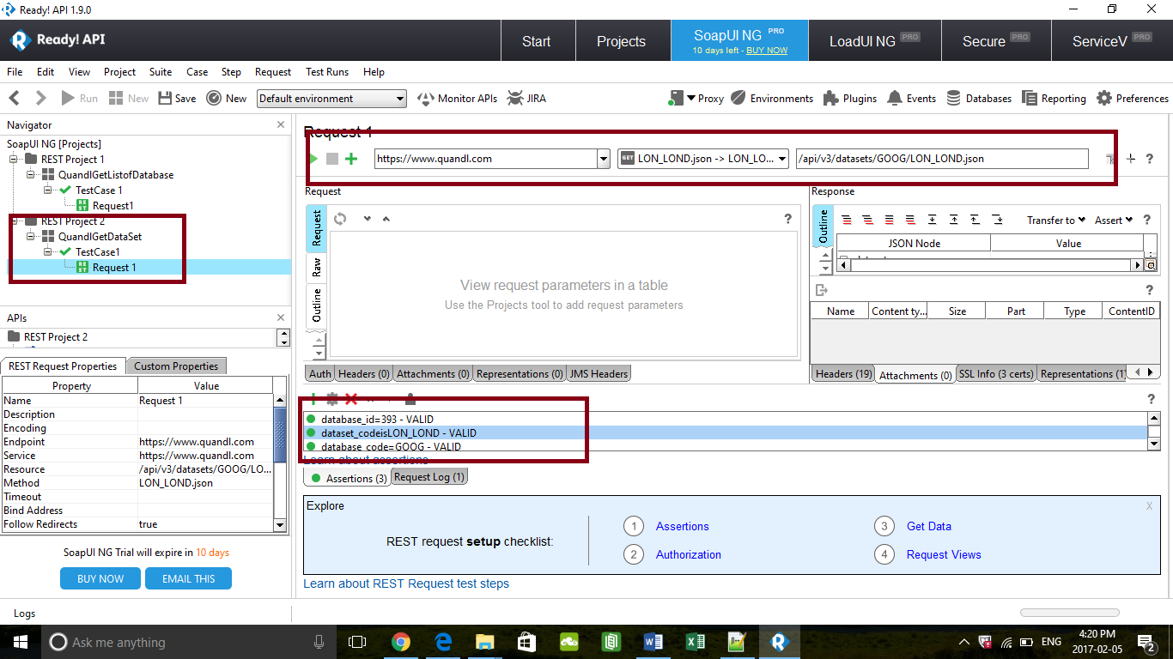

**TEST 3: Ensure  our  datatable  API  returns  data  for  the  `WIKI`  database  with  a  valid  API  key**

Location of file on GitHub: Quandl\API Test\REST-Project-3-DataTableWIKI

1.Please follow the steps from above to execute the test case.

2.Follwed the registration steps for signup in the Quandl.com to secure the API key.

3.Verified the following test scenarios from the API response :

1)vendor code is WIKI

2)Datatable code is PRICES

